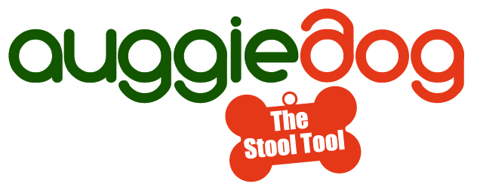

Media Kit

Auggiedog No-Touch System

Auggiedog is the first ever no-touch system that picks up, holds and carries what your pal leaves behind. Testimonials indicate that Auggiedog has quickly become man’s next best friend!

5-in-1 Power Stool Tool
Auggiedog is an innovative 5-in-1 power stool tool designed to pick up dog poop with the click of a button The Auggiedog is perfect for walks even at night with two built in LED lights, and a clicker to making training a cinch. With the adjustable length shaft and self- standing cap, Auggiedog acts as a walking stick that can be used by anyone and is perfect for those who can’t stoop to pick up poop!

Backyard maintenance is fast and fun with Auggiedog. Simply pull the trigger on the easy grip handle and watch the dog, goose or racoon poop disappear. The patented system can hold 2-5 pick-ups depending on the size of the animal and comes with a 1 year manufacturer’s warranty.

Auggiedog also comes with its own self-cleaning station where it can be quickly cleaned and stored until the next use. One charge will last 2-3 weeks based on normal use.

Environmentally Friendly
The Auggiedog is environmentally friendly, eliminating the need to use plastic bags. Dispose your dog’s waste in a variety of ways: flush, compost or eject into the garbage. quickly, cleanly and easily. Auggiedog can save you up to $50 a year in plastic bags. The biodegradable cleaning solution will keep your Auggiedog smelling fresh and ready for each use.

Award Winning
The American Pet Association (APA) gave Auggiedog a Five Star Approval Rating and stated “When used properly, Auggiedogy easily picks up pet waste and makes cleaning up after your pet a breeze.” and “Very well made, high quality units”.
Auggiedog is also proud to be a winner of the 2012 Pet Expo Award!

Purchase
Auggiedog is available to be purchased online at www.auggiedog.com and www.amazon.com.

Social Media Presence

Facebook: Auggiedog
Twitter: @auggiedogday
YouTube: Introducing Auggie Dog

Images

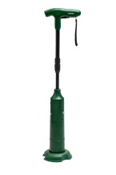 | 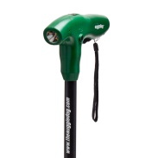 | 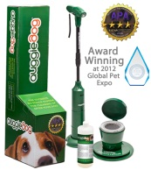 | 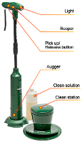 | 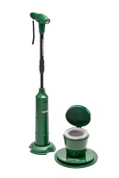
Auggiedog with Cap | Auggiedog Handle | Auggiedog Award | Auggiedog Features | Auggiedog with Cleaning Station
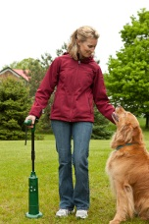 | 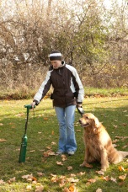 | 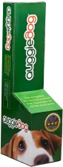 | 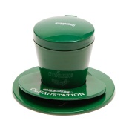 | 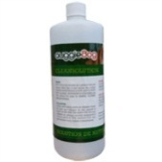
Auggiedog as walking stick | Auggiedog in use | Auggiedog Package | Auggiedog Cleaning Station | Auggiedog Biotdegradable Cleaning Solution

For more information please contact:

Taylor Russell, GCL Solutions Group, 1 877 898 8408 email: info@auggiedog.com

